AI ASSISTANT CODING
ASSIGNMENT 12.3
TASK1:
PROMPT:
I am building a Python program to manage student records for a placement drive. Each student has a name, roll number, and CGPA. Can you help me write a program to store multiple student records using a suitable data structure (like list of objects or dictionaries)?
CODE:
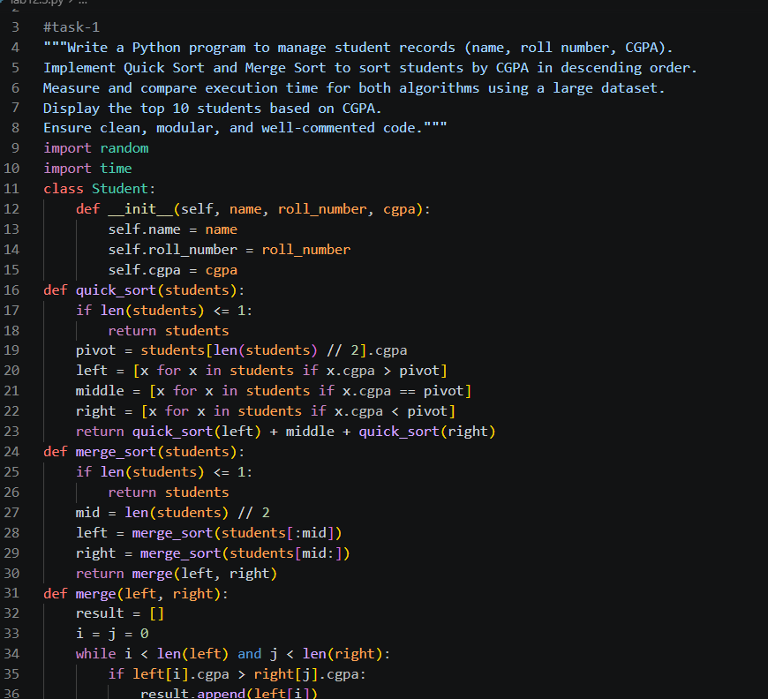
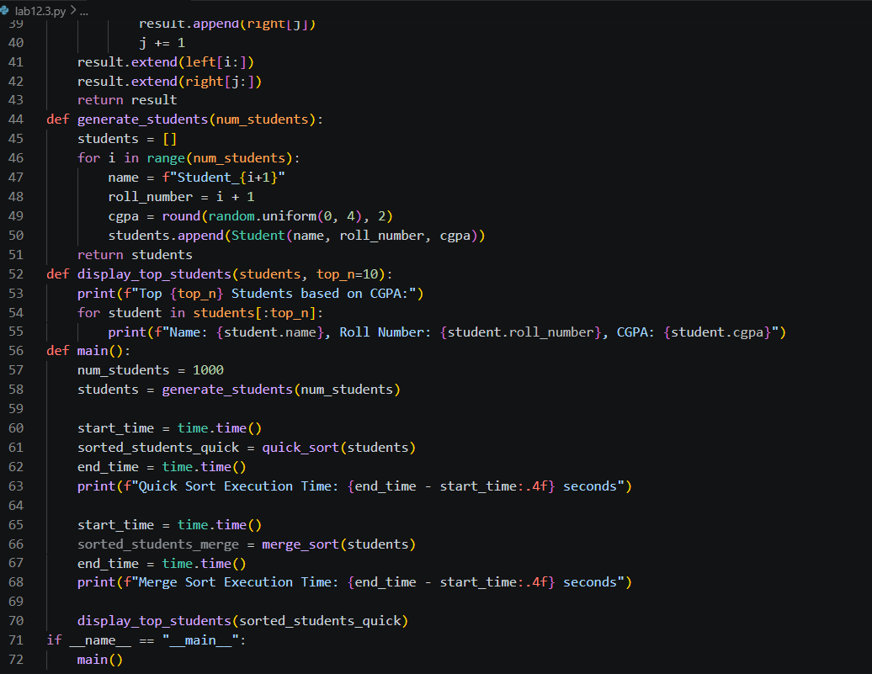
OUTPUT:
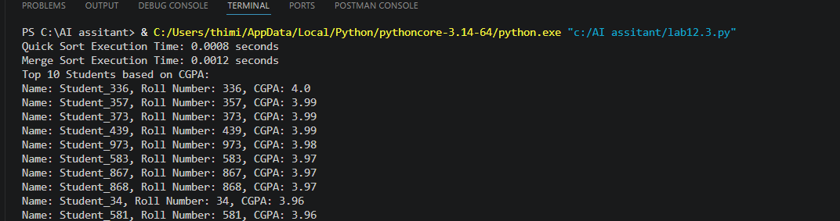
TASK2:
PROMPT:
I have a list of student records with CGPA values. Can you implement Quick Sort in Python to sort the students in descending order based on CGPA? Please keep the code simple and readable.
CODE:
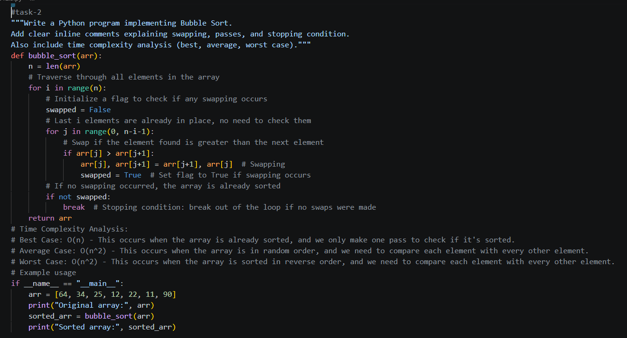
OUTPUT:
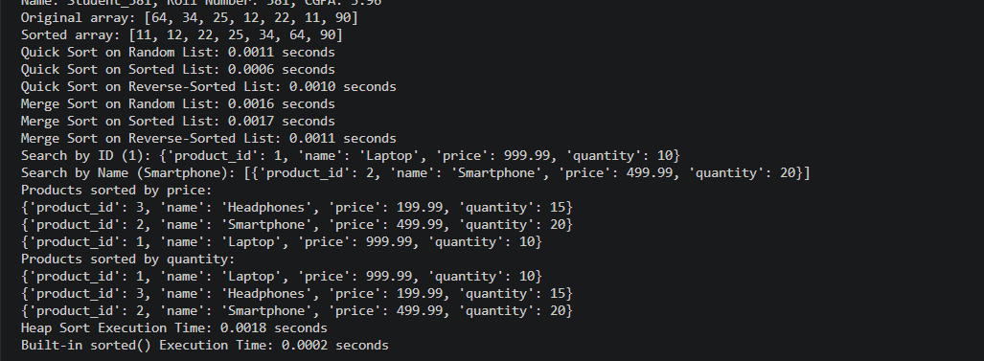
TASK3:
PROMPT:
Can you implement Merge Sort in Python to sort student records by CGPA in descending order? Also explain how the merge process works in this case.
CODE:
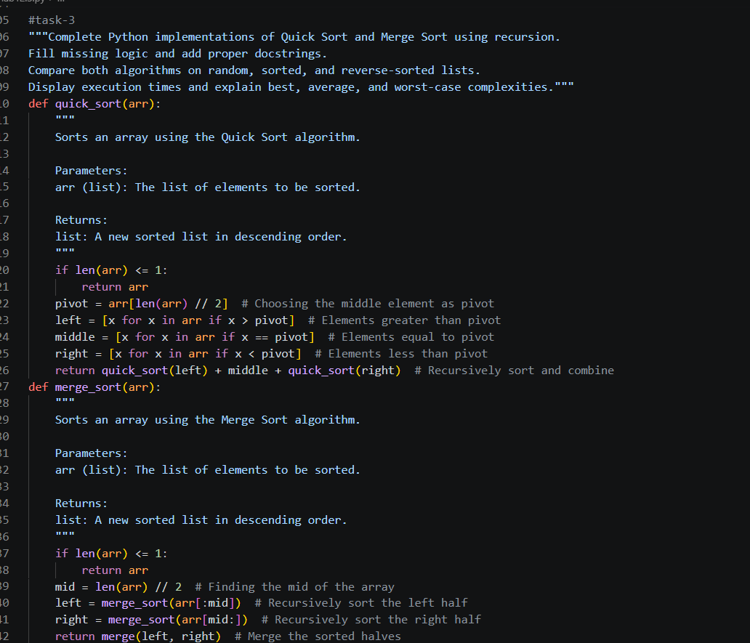
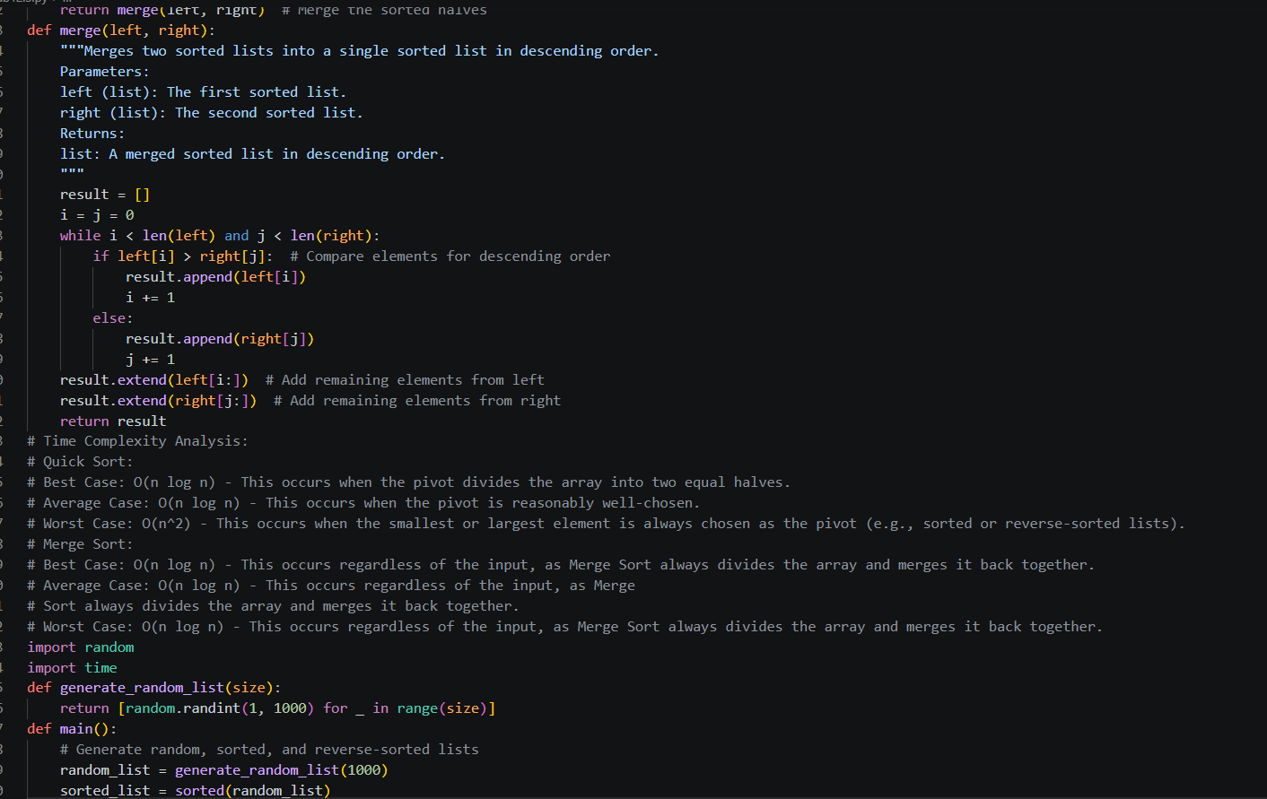
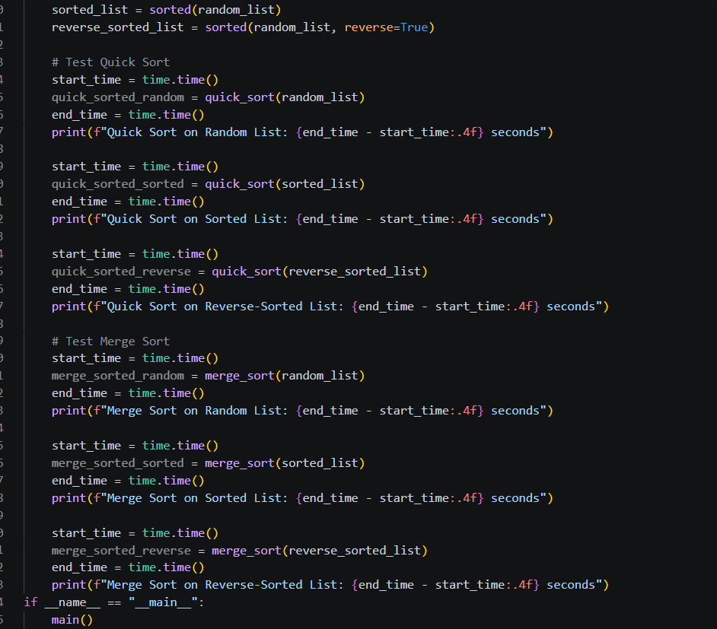
OUTPUT:
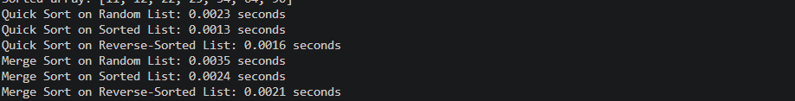
TASK4:
PROMPT:
I want to compare the runtime performance of Quick Sort and Merge Sort on a large dataset of student records. Can you show me how to generate random student data and measure execution time using Python?

CODE:
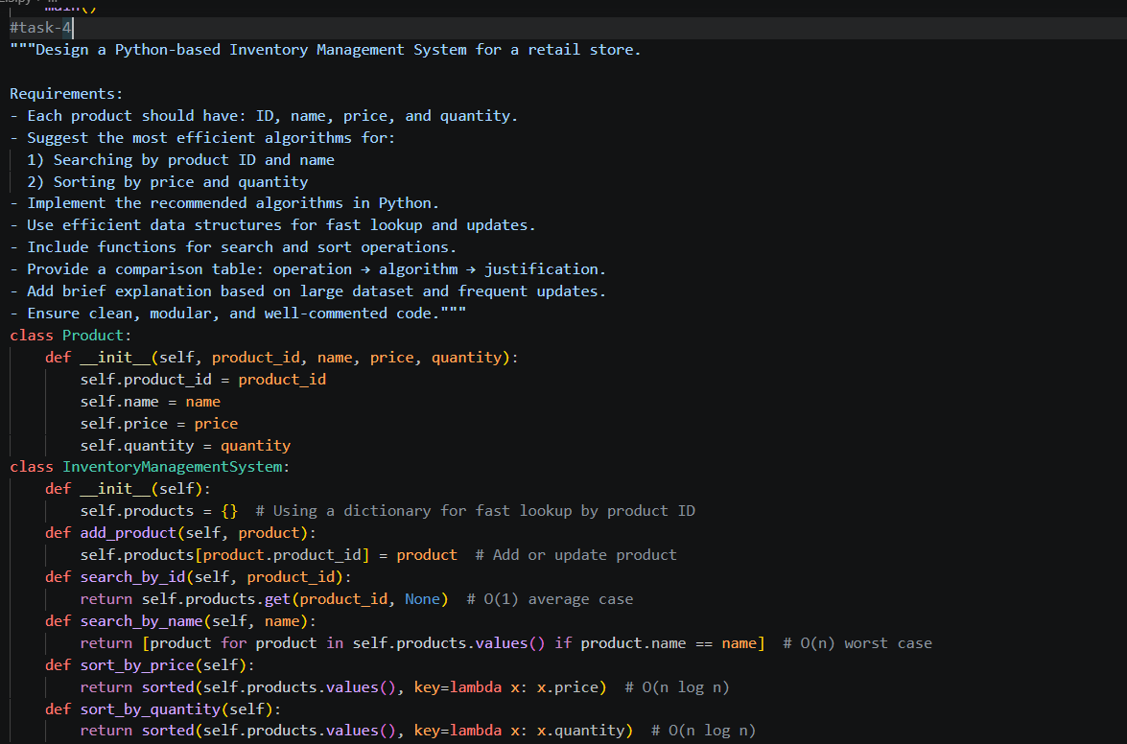
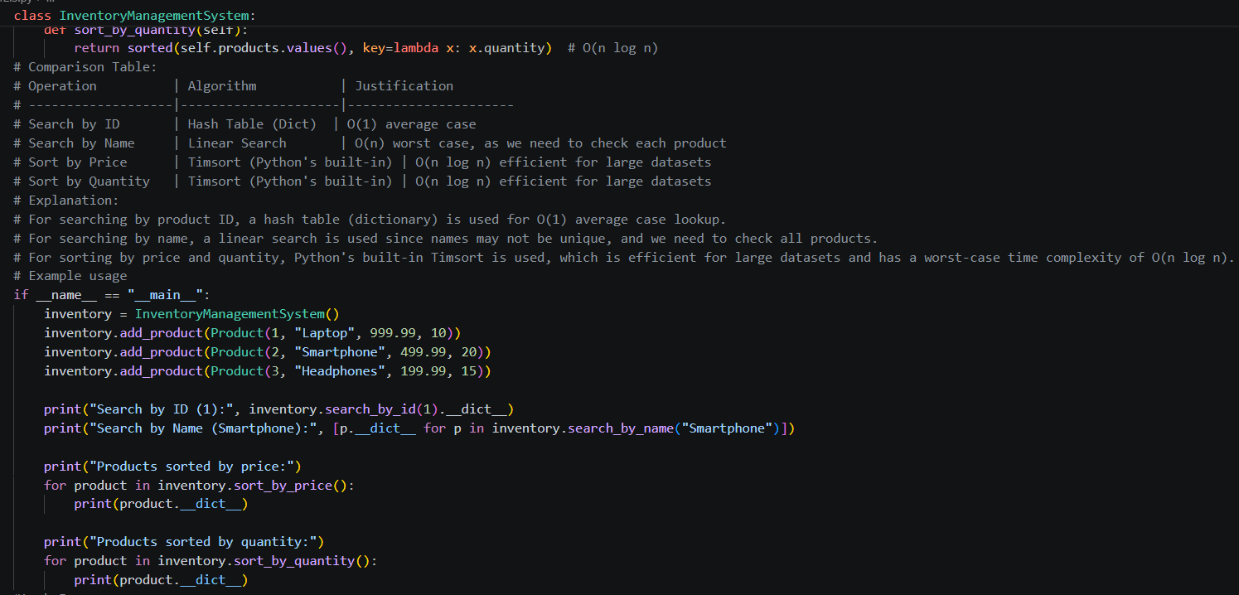

OUTPUT:

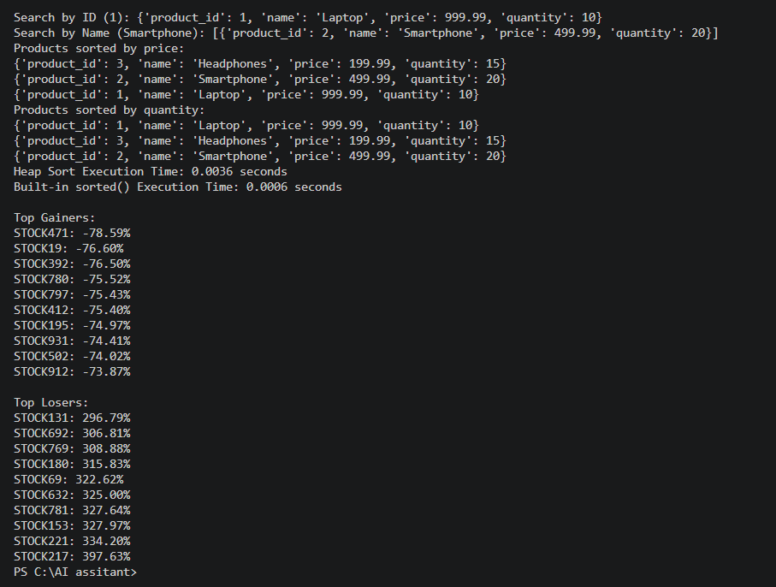
TASK5:
PROMPT:
After sorting student records by CGPA, can you write a function to display the top 10 students clearly with their name, roll number, and CGPA?
CODE:
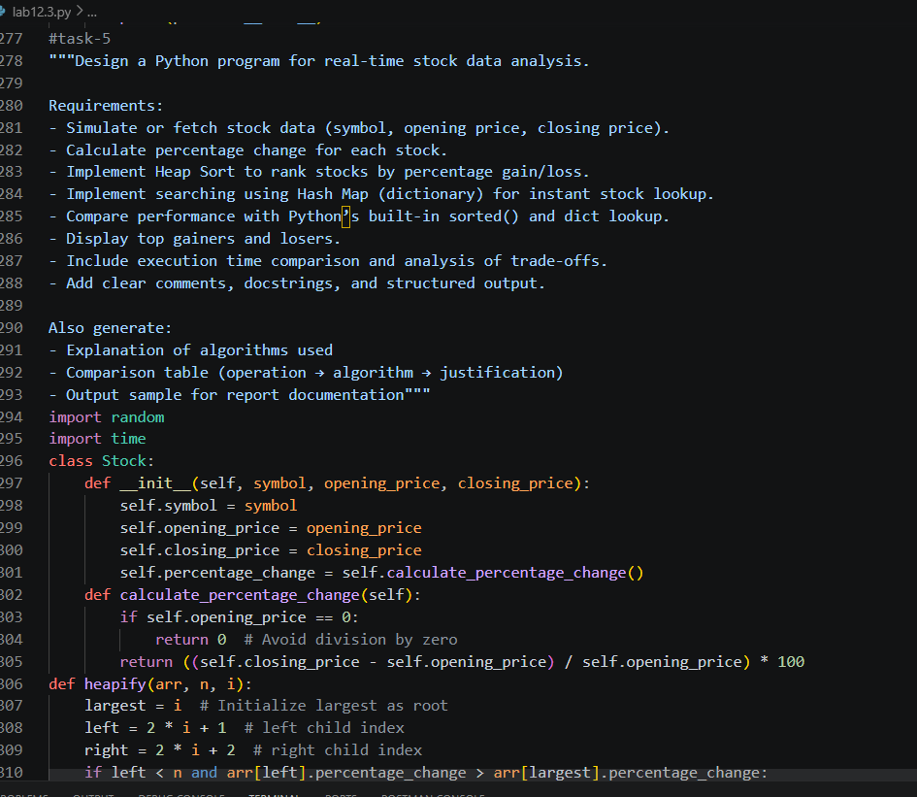
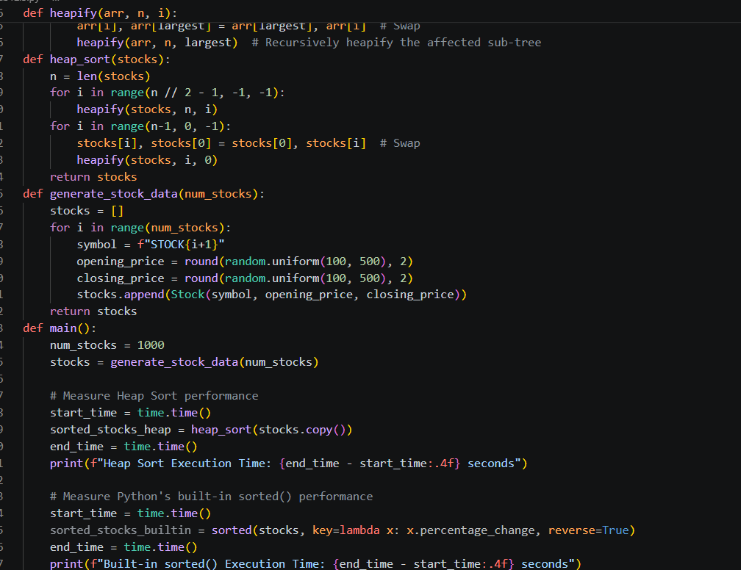
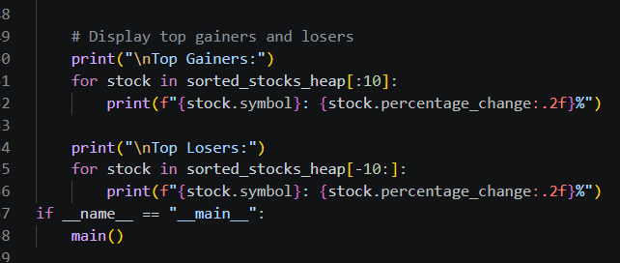
OUTPUT:
